JOBSHEET 2 CLASS AND OBJECT



**From:**

AL AZHAR RIZQI RIFA’I FIRDAUS

**Class:**

1 I

**Absence:**

01

**Major:**

Information Technology

**Study Program:**

Informatic Engineering

# COMPETENCIES

* 1. Students understand the most basic concept of object, class and object
  2. Students are able to declare class, attribute and method
  3. Students are able to create object (instantiation)
  4. Students are able to access attibute and method of object
  5. Students are able to implement constructor

# OVERVIEW

Generally, there are 2 paradigms in developing programs. They are Procedural Programming and Object Oriented Programming. In Procedural Programming, the program is organized as a collection of functions or subprocesses, while ObjectDOriented Programming (OOP) composes program by collection of objects and there are interactions between objects. Object becomes main concern in OOP. Because of the importance of object in OOP, understanding the context of object becomes very principal in developing the program. The OOP concept translates real life into programming concepts.

In the real life, **OBJECT** is a real object that could be found around us. It means that the object must be a real thing. Something that is not real, just a prototype/design/concept could be classified as object. If we see more detail on an object, we will find that it contains of 2 main characteristics, it has something and it can do something. Something owned by an object called as **attribute**/property/data/character/state/field. And something that could be performed by an object called as **method**/behaviour/function/procedure.

Every object must come from a design/blueprint. The design will define the template from which the object will be created. Design/prototype/template/blueprint from which objects are created know as **CLASS**. It means that the object is the instance of a class. It is a real thing created from class. The process creating an object from a class known as **INSTANTIATION**. From here, we can conclude that, there is no object that exists without a class from which it is created. We need to define a class before creating an object. After creating an object, we can manipulate it. We could not do any manipulation to a class instead, because it is still a design/concept.

Declaring class in source code is so simple. Keyword **class** takes place on it. Below is the format of class declaration.

# class ClassName {

*// attributr*

*// method*

# }

After declaring a class, we need to declare attributes and methods owned by this class. Attributes depict data/property owned by class, while methods depict process that could be performed by class.

Below is the format of attribute declaration:

# dataType attributeName;

While below is the format of method declaration:

# dataType methodName (dataType parameter){

*// method body*

# }

Note:

* Data type of method : it determines the return value of the method. If we need the method not to return any value, then we can give it void datatype. But if we need the method to return a value, then we must declare it with nonDvoid datatype. It could be int if we need the method to return int value, String data type for a method with String return value, etc.
* Parameter of method : it is used to pass the value from outside of method to be processed inside the method. If we need to be able to pass values from outside of method when we call the method, then we need to make the method to have parameters. Of course the values that will be passed through parameters will be processed inside method.

Example:

# class Bicycle {

**double** speed;

**int** gear;

**void** changeGear(**int** g){ gear = g;

}

**void** speedUp(**double** v){ speed = speed+v;

}

**void** applyBrakes(**double** v){ speed = speed-v;

}

**void** printStates(){ System.out.println(“Speed = ”+speed); System.out.println(“Gear = ”+gear);

}

# }

Class that is already created, could not be used as long as we does not create an object from that class. Thus, the next step after creating a class is creating an object from the class (instantiation). Instantiation could be written as follows:

ClassName objectName = **new** ClassName();

Example:

Bicycle b = **new** Bicycle();

Once we have finished to create an object, further we can use or manipulate it. For example, we can assign value to its attributes, we can call its method as well. Below is the way how we can access attribute of the object:

b.speed = 10;

b.gear = 1;

And below is the way to call method of the object: b.speedUp(5); b.changeGear(1); b.printStates();

The design/structure of a class could be visualized by using **CLASS DIAGRAM**. The following image shows the example of class diagram of class Bicycle.

|  |
| --- |
| Bicycle |
| speed: double gear: int |
| speedUp(v: double): void applyBrakes(v: double): void changeGear(g: int): void  printStates(): void |

When creating an object from a class (instantiation), if we look it closer, we will find that actually there is a special method that runs to create the object. A special method that runs at the instantiation process that creates an object is called as **CONSTRUCTOR**. The characteristics of constructor are:

* Constructor name is similar with the class name
* Constructor does not have any data type
* Constructor will never need a **return** statement
* Constructor only can be run at the instantiation process The following sintax will give the formate to declare constructor.

NamaClass(tipeData parameter){

Example:

}

Bicycle(){

// *constructor body*

}

Bicycle(int g, double v){

// *constructor body*

}

There are some naming conventions that we need to care about:

* + Class Name : Class name must be a noun, and it is written in Capital Camel Case. For example: Bicycle, InternationalStudent
  + Atribut Name : Attribute name must be a noun, and it is written in Camel Case. Example: name, totalAmount
  + Method name : method name must be a verb and it is written in Camel Case. Example: print(), calculateDiscount()

# LABS ACTIVITY

**PART 1 – NetBeans Installation**

NetBeans is integrated development environment that could be used to manage Java program. By using NetBeans, writing Java program becomes easier (because of syntax completion and javadoc feature) and becomes less of typo. The current latest version of NetBeans is version 10.

1. Your computer must install JDK first, before installing NetBeans. The JD installer could be found at <http://www.oracle.com/technetwork/java/javase/downloads/index.htm> l .
2. Download NetBenas installer at https://netbeans.org/downloads/
3. Run the installer, and follow the installation steps
4. Run the NetBenas
5. Create a new Project, **File > New Project**. In the **Categories** panel choose **Java** and in **Projects** panel choose **Java Application**. Then give a **Project Name** (for example **AlgorithmAndDataStructure**), **Project Location** and **Project Folder**, and **uncheck Create Main Class** option.
6. Press the **Finish** button. The new project will be created and this project that will be used by us to store all code will be developed this semester for this course ☺
7. Right click at **Sources Packages > New > Java Package**. Type **minggu1** as the package name. Then, a new package named **minggu1** will be created.
8. Right click at **minggu1 > New > Java Class**. Type **HelloNetBeans** as the class name**.** And in the editor HelloNetBeans, complete the main method as follows:

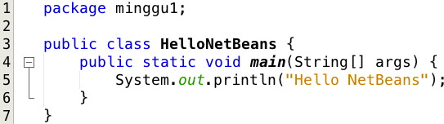

1. Right click at class **HelloNetBeans** > **Compile** to complie this source code
2. Right click at class **HelloNetBeans** > **Run File** to run this file

# PART 2 – Declaring Class, Attribute and Method

namaBarang: String jenisBarang: String stok: int

Barang

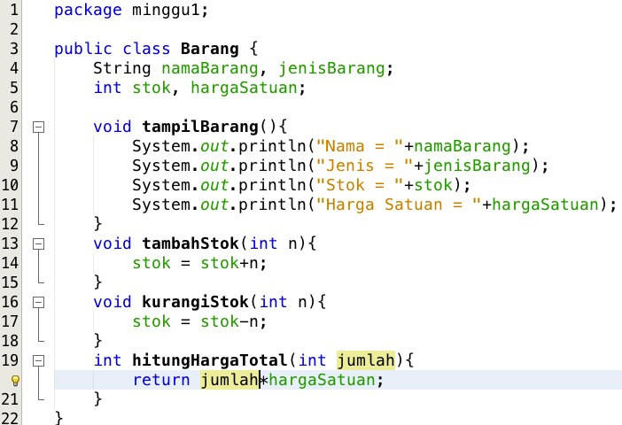

tampilBarang(): void tambahStok(n: int): void kurangiStok(n: int): void hitungHargaTotal(jumlah: int): int

hargaSatuan: int

Based on the class diagram above, we will create a java program.

* 1. We have created a new project at PART 1. We will still use it ☺
  2. In the package **minggu1**, create a new class named **Barang**.
  3. Based on the class diagram above, complete the class declaration by declaring the correct attributes and methods:
  4. Try to Run class/file **Barang**. Does it works?

# PART 3 – Instantiating Object and Accessing Atribut&Method of the Object

1. We have created class Barang. And to start using it, we need to create an object from it. After creating the object, of course we will be able to access its attributes and methods.
2. In the package **minggu1**, create a new class named **BarangMain**. Then, create a **main** method in the class **BarangMain**
3. In the method **main()**, do the instantiation, and then access the attributes and methods of the created object

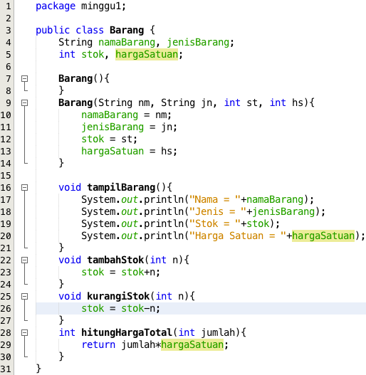

1. Run class **BarangMain** and observe the result.

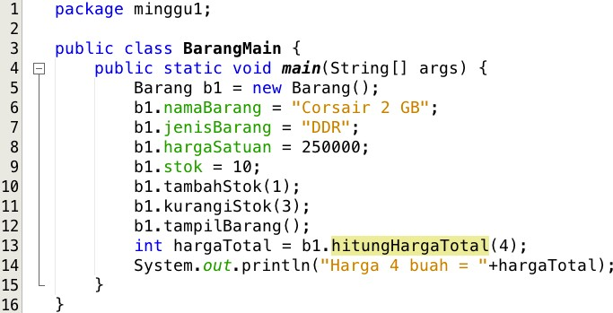

# PART 4 – Constructor

1. Look again at class **Barang**. Add in the class **Barang** 2 constructors. They are default constructor and parametric constructor.
2. Now move to class **BarangMain**. Create one more object, but now we will use parametric constructor at the instantiation.

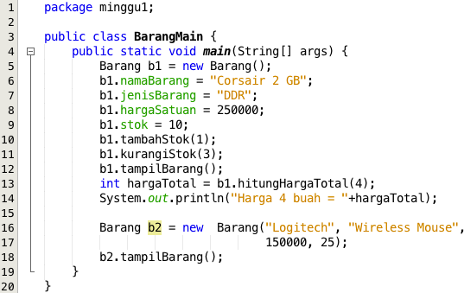

1. Run the class **BarangMain** and observe the result.

# QUESTION

* 1. Mention 2 characteristics of class/object!

1. Encapsulation: Classes and objects in object-oriented programming (OOP) typically exhibit encapsulation, which means that the internal workings of an object are hidden from the outside world. This is achieved by defining public methods and properties that can be accessed by other parts of the program, while keeping the implementation details private. Encapsulation is important for creating modular, maintainable code.
2. Inheritance: Inheritance is another characteristic of OOP, whereby a class can inherit properties and methods from a parent class. This allows for code reuse and helps to create a hierarchical class structure. For example, you might have a base class called "Animal", which contains common properties and methods for all types of animals, and then have more specific classes like "Dog" and "Cat" that inherit from the Animal class and add their own unique properties and methods.
   1. What is the keyword used to declare a class?

public class Myclass {

}

* 1. In the class **Barang** at the **Part 2**, how many attributes owned by that class? What are they?

There are 4 attributes such as namaBarang with String, jenisBarang with String, stok with int, hargaSatuan with int.

* 1. In the class **Barang** at the **Part 2**, on which line of code are the attributes declared?

line 4 and line 5

* 1. In the class **Barang** at the **Part 2**, how many methods owned by that class? What are they?

There are 4 method such as tampilBarang, tambahStok, kurangStok, hitungHargaTotal.

* 1. In the class **Barang** at the **Part 2**, on which line of code are the methods declared?

From line 7 to 21.

* 1. In the method **kurangiStok()** in class **Barang**, modifiy the method so that it will check the availability of **stok** before subtracting the **stok**! Then it will not be any subtraction if the **stok** is already less then or equals to zero.

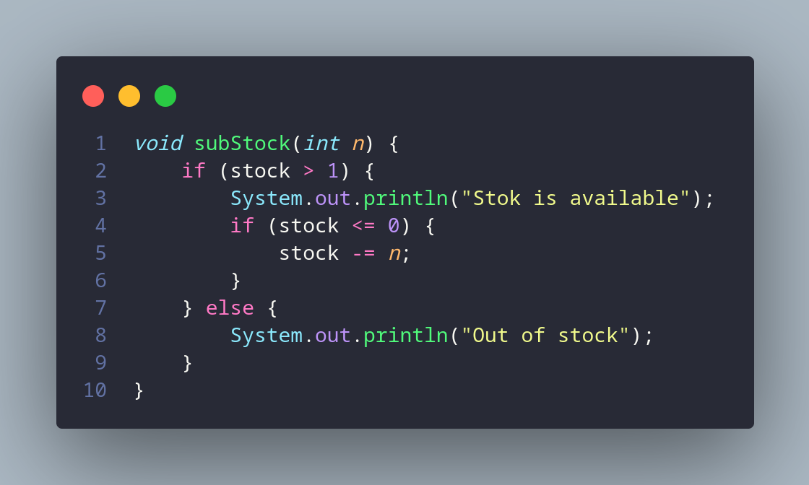

* 1. Please give your explanation, why is method **tambahStok()** created with an int parameter? What is the use of that parameter int that method?

Because int parameter used to process number from outside method.

* 1. Why does method **hitungHargaTotal()** have a nonDvoid (int) data type? What is it for?

Because in method hitungHargaTotal() there is result which is return value of calculate price total.

* 1. Why does method **tambahStok()** have void data type?

The reason that the method addStock() has a void return type is because it does not need to return any value to the calling code.

* 1. In class **BarangMain**, in **Part 3**, on which line of code does the instantiation process run? And what is the name of the resulting object?

In line 5 an name object is b1.

* 1. How do you access the attributes and methods of the object?

nameObject.nameMethod();

* 1. In class **Barang** in **Part 4**, on which line of code is the parametric constructor declared?

In line 9 to 14.

* 1. In class **BarangMain** in **Part 4**, what does actually we do on line of code 16?

To print attribute inside class.

* 1. Try to create another object called **b3** from class barang by using the parametric constructor of class **Barang**.

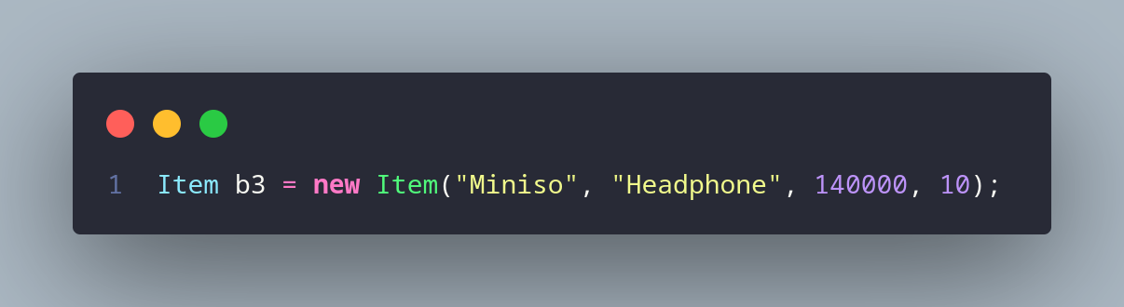

# TASK

* 1. Create the program based on the class diagram below!

|  |
| --- |
| Lingkaran |
| PHI: double r: double |
| hitungLuas(): double  hitungKeliling(): double |

Note:

* + - Method hitungLuas() will calculate the area of the circle
    - Method hitungKeliling() will calculate the surrounding of the circle

Code:

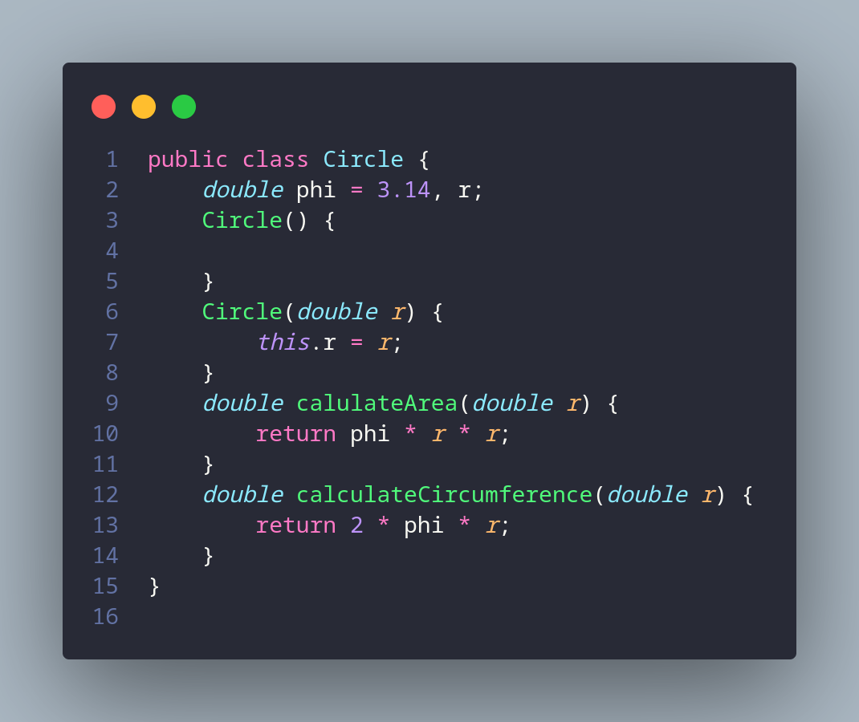

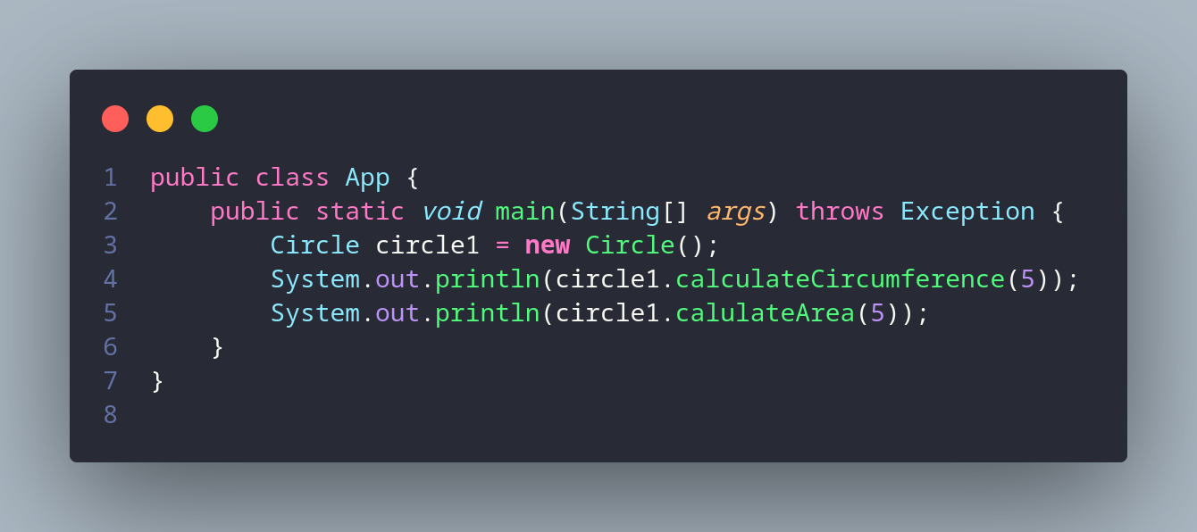

Result:

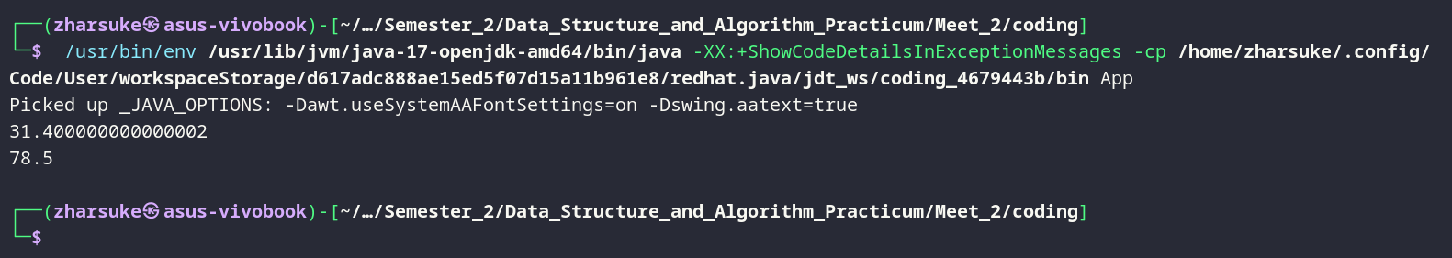

* 1. In the video game rental and shop, the most important data that they manage is RentalTransaction. It contains memberId, memberName, gameName, dailyPrice and dayRent (how many days it will be rent). It has a method to print the rental data and the price that should be paid by member. Please create a class diagram of the class and make the code!

Code:

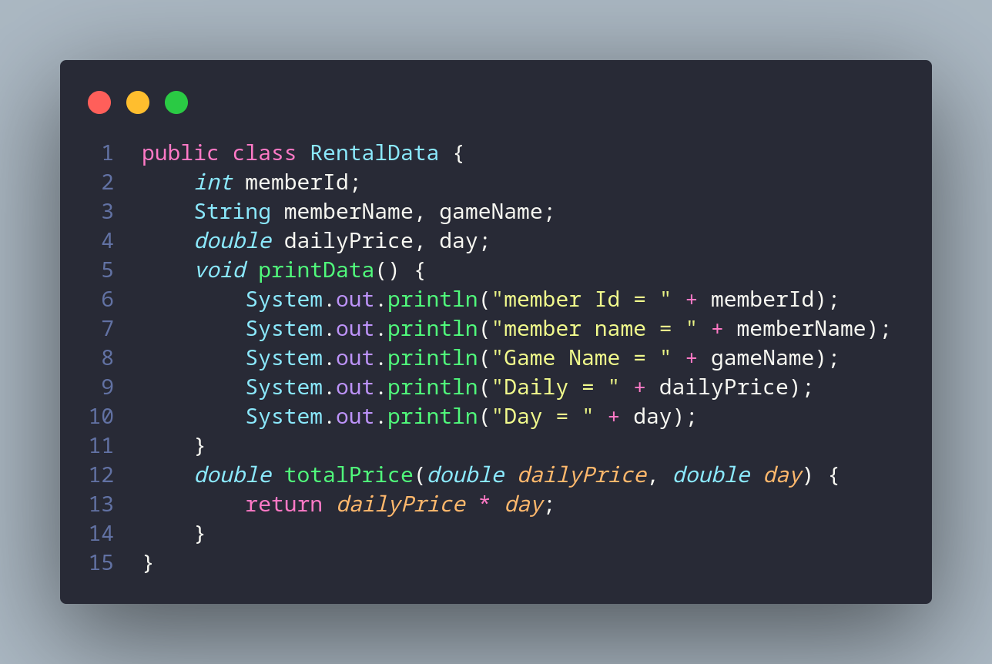

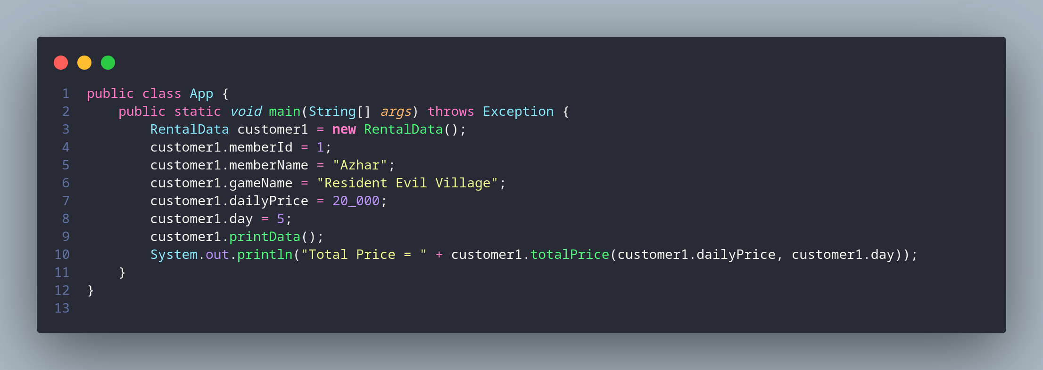

Result:

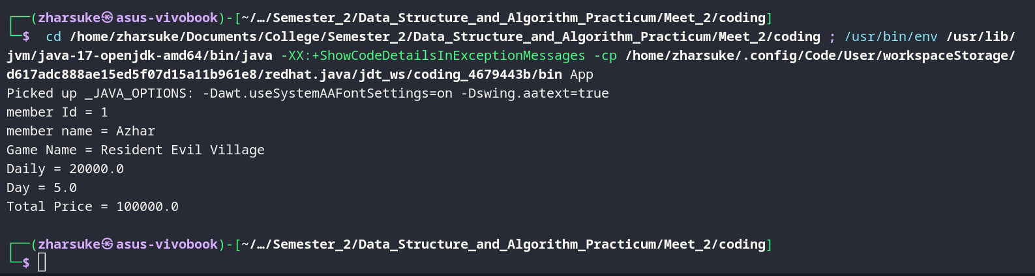

* 1. Implement the code of this class diagram!

|  |
| --- |
| Item |
| name: String  unitPrice: int qty: int |
| calculateTotalPrice(): int calculateDiscount(): int  calculateFinalPrice(): int |

* + - Method calculateTotalPrice() will multiply the quantity of item and the unitprice
    - Method calculateDiscount () will calculate the discount, with the role:
      * If total price > 100000, the discount will be 10%
      * If the total price between 50000 D 100000 the discount will be 5%
      * If the total price < 50000 it will be no discount
    - Method calculateFinalPrice () will calculate the price should be paid (total price minus discount)

Code:

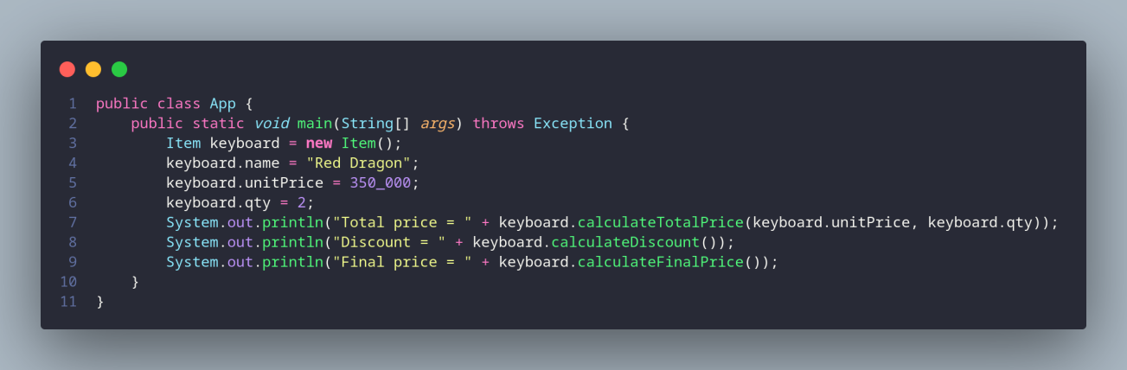

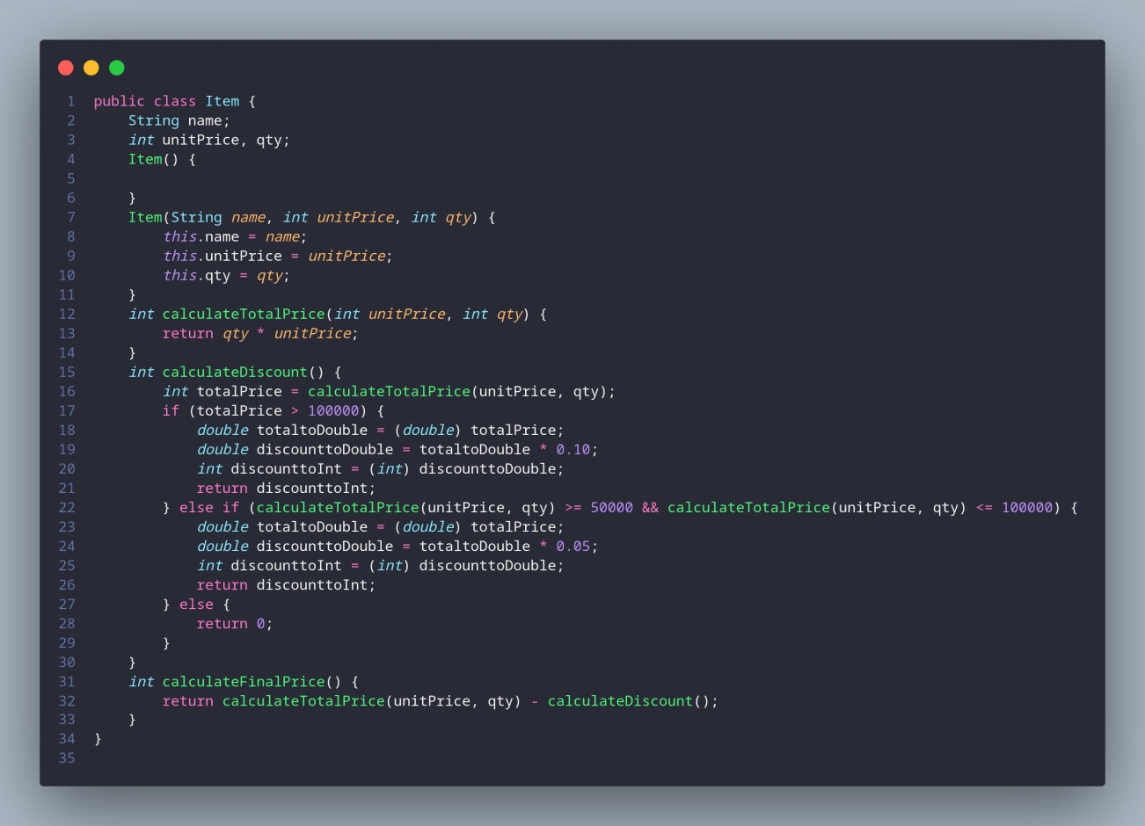

Result:

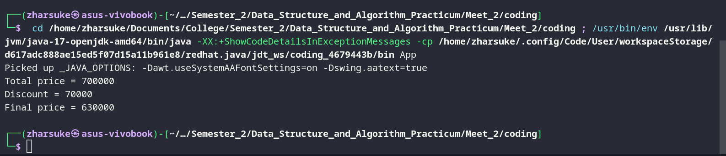

* 1. Implement the code of class diagram below!

|  |
| --- |
| PacMan |
| x: int y: int  width: int height: int |
| moveLeft(): void moveRight(): void moveUp(): void  moveDown(): void |

|  |
| --- |
| printPosition(): void |

* + - Attribute x depicts the horizontal posisiton/coordinat of Pacman, while attribute y depicts the vertical coordinat
    - Attribute width is for canvas width, and attribute height is for the height of the canvas
    - Method moveLeft() will move Pacman to the left (coordinat x will decrease), while moveRight() will move Pacman to the right (coordinat x will increase). The value of x will range from 0 to width value
    - Method moveUp() will move Pacman to the upper position (coordinat y will decrease), while moveDown()will move Pacman to the lower position (coordinat y will increase). The value of y must be between 0 to height value

Code:

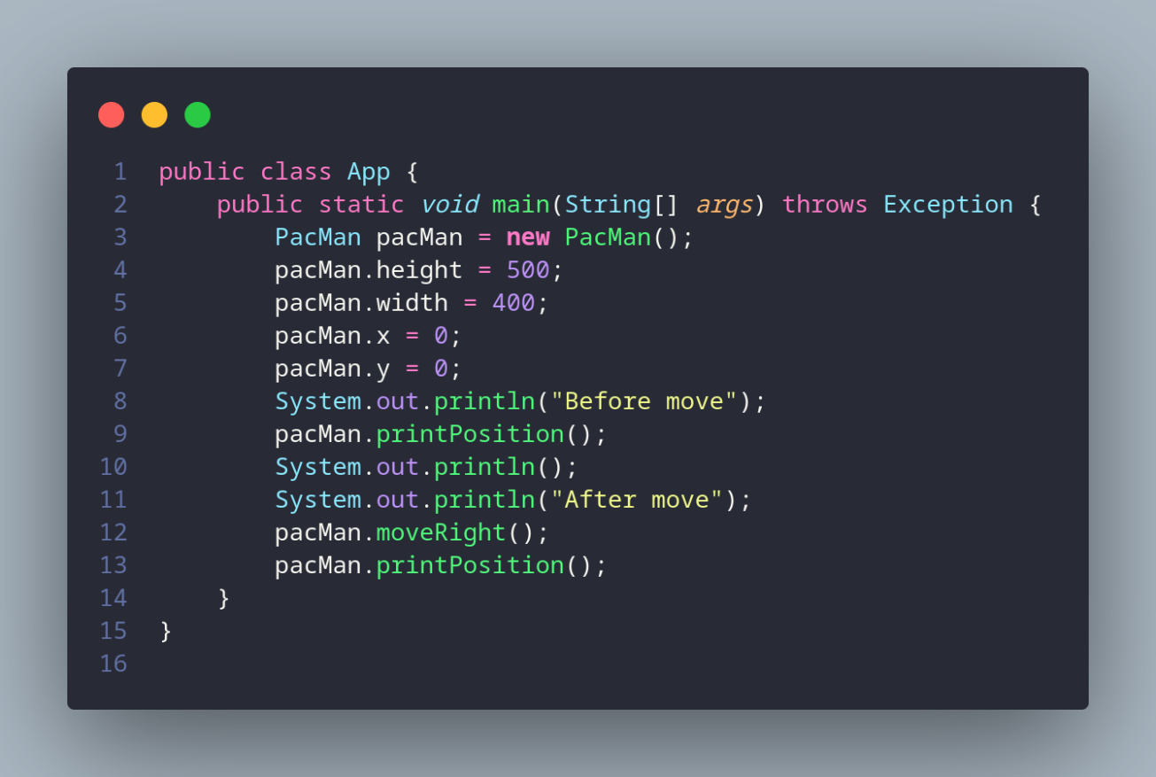

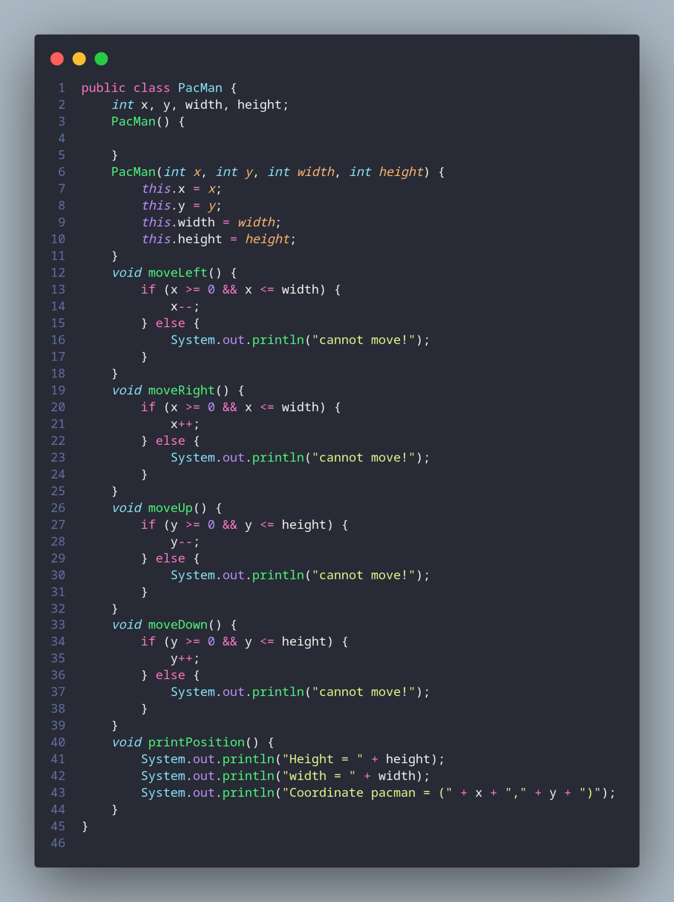

Result:

